**Menoufia University**

**Faculty of Electronic Engineering**

**Embedded Systems**

**(Task-2)**

**DEPARTMENT:**

* **Department of Engineering and Computer Science, 4rd year**

**STUDENT NAME:**

* **امجد مجدي فتحي سيد احمد**
* **سكشن (1)**

**TASK #2 (RGB Led)**

**In this task, we will light three LEDs, red, then green, then blue. When moving from red to green, the two colors will be combined and shown through the RGB LED. When moving from green to blue, the two colors will be combined and shown through the RGB LED. When moving from blue to red, the two colors will be combined and display through RGB LED.**

**Required components for this lab:**

* **Breadboard**
* **Wires (male - male)**
* **3 Led (Red, Green, Blue).**
* **6 resistor in range of 220Ω to 1KΩ.**
* **1 RGB Led.**

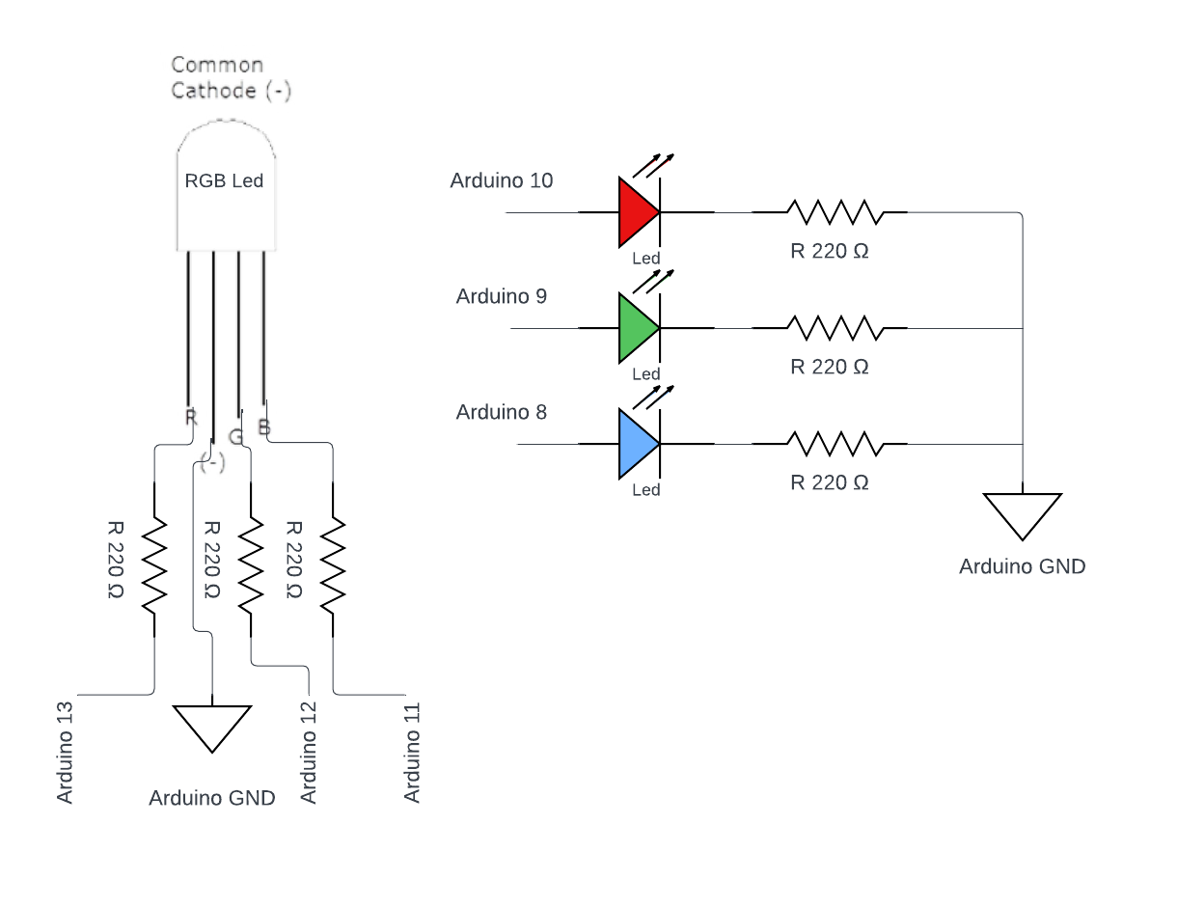**Circuit diagram**

**Code**

#define led_red 10

#define led_green 9

#define led_blue 8

#define rgb_led_red 13

#define rgb_led_green 12

#define rgb_led_blue 11

void setup() {

  pinMode(rgb_led_red,OUTPUT);

  pinMode(rgb_led_green,OUTPUT);

  pinMode(rgb_led_blue,OUTPUT);

  pinMode(led_red,OUTPUT);

  pinMode(led_green,OUTPUT);

  pinMode(led_blue,OUTPUT);

}

void loop() {

  digitalWrite(led_red, HIGH);

  delay(2000);

  digitalWrite(led_red, LOW);

  analogWrite(rgb_led_red, 255);

  analogWrite(rgb_led_green, 255);

  analogWrite(rgb_led_blue, 0);

  digitalWrite(led_green, HIGH);

  delay(2000);

  digitalWrite(led_green, LOW);

  analogWrite(rgb_led_red, 0);

  analogWrite(rgb_led_green, 255);

  analogWrite(rgb_led_blue, 255);

  digitalWrite(led_blue, HIGH);

  delay(2000);

  digitalWrite(led_blue, LOW);

  analogWrite(rgb_led_red, 255);

  analogWrite(rgb_led_green, 0);

  analogWrite(rgb_led_blue, 255);

}

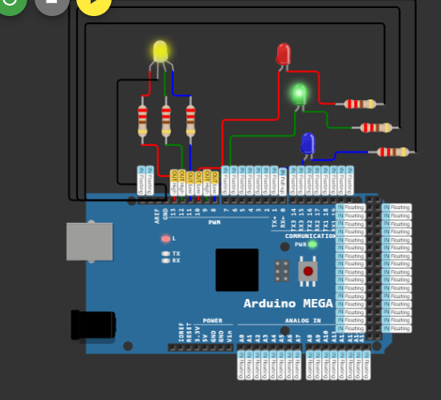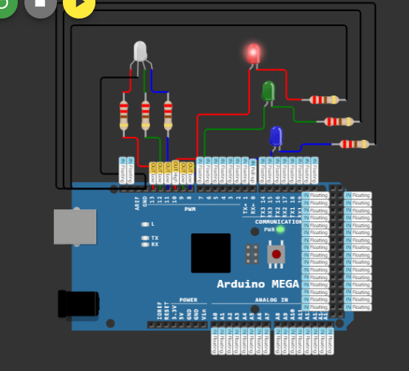**Test**

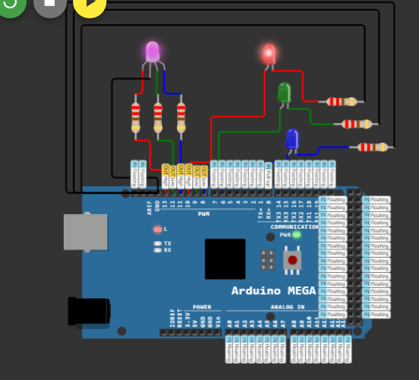

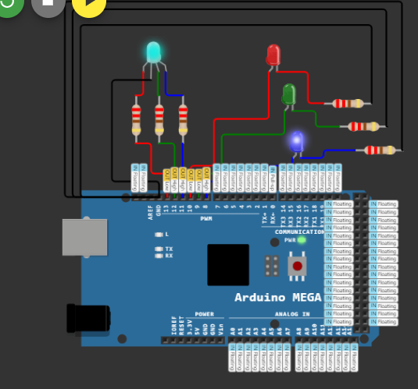

**My Link to run code:** [**https://wokwi.com/projects/391647775710324737**](https://wokwi.com/projects/391647775710324737)